Martha Guzman
Assignment 1.2 Advanced Python CSD 325
6/6/2026

- https://github.com/Martha-Codes/csd-325.git
- Screenshot of repository:
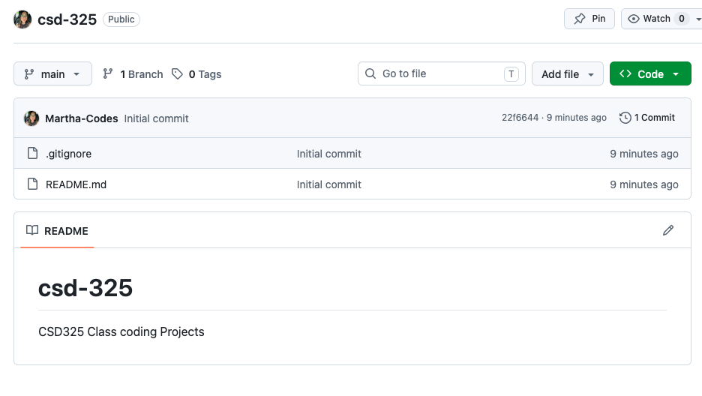
- Screenshot of Directory:

